**Company Profile**

**Company: Shivansh Enterprises Director: D Karade**

Shivansh Enterprises is authorized distributor and applicator for Elantas Beck India Ltd and authorized applicator for Flowcrete India Ltd.

We are the sister concern organization of Sai Vikas Coating Pvt. Ltd., working closely in collaboration to execute and deliver the projects in the following business functions;

* Industrial Flooring
* Coving
* Food Grade Epoxy Coating
* Protective/Interior Wall Coating
* Waterproofing
* Marine Deck Covering
* Structural Repair
* Building Maintenance Work

We have a well trained team of 90 technicians to get the best of the results in the projects we execute.

They are a well trained team, who are trained at our authorized dealer facilities to get the best of the skills.

We execute the projects of our clients from concept to realization.

Our aim/mission is to deliver the best in the class quality of work and on time delivery and make sure the client is not only satisfied but also delighted with the results.

Our relationship not only remains with the clients till the execution of the projects, but we make sure to give the maintenance-service to our clients on call basis as and when required.

Our Vision is to be among the leading applicators in India.

In last over ten years we have carried out many major projects for Pharmaceuticals, Food, Automobile and Engineering industries.

Following are some of our key clients, with whom we have worked to the utmost satisfaction results over a period o decade;

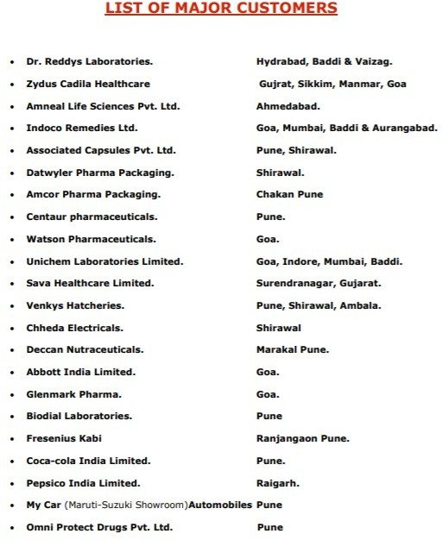

Project Snaps for reference.

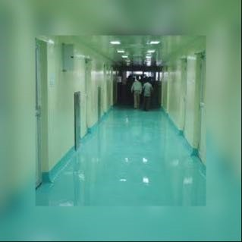



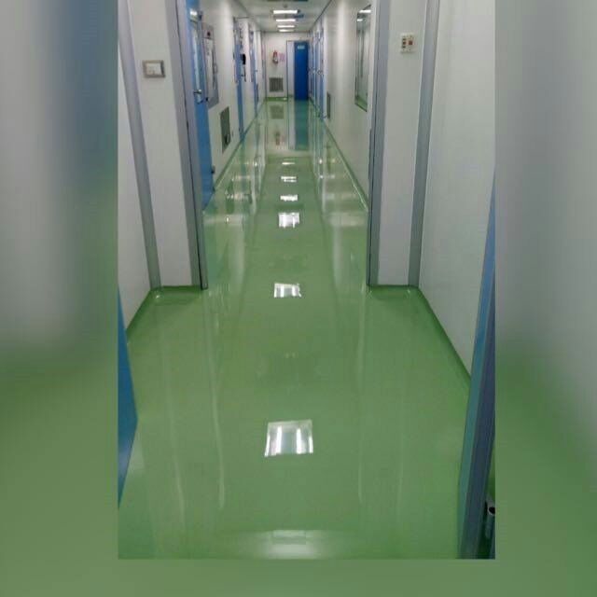

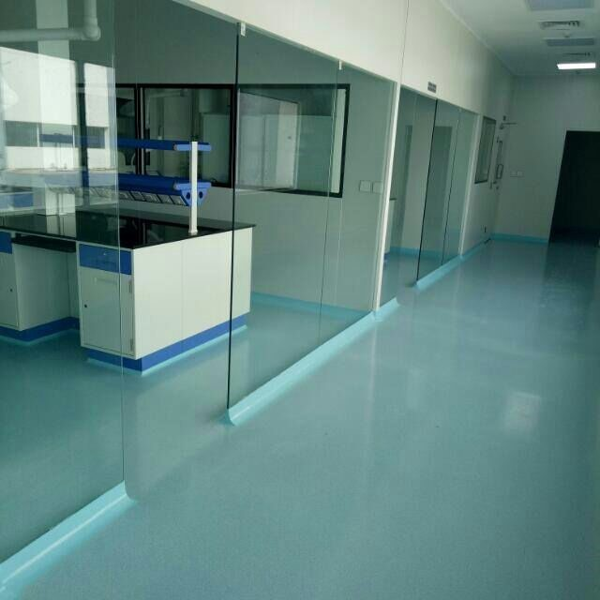

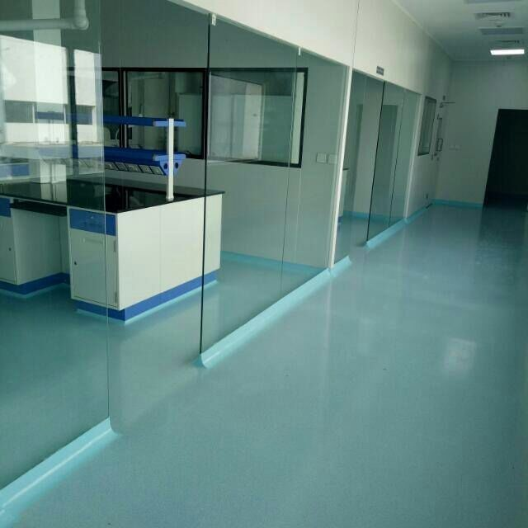

For any further enquiries or clarification, please contact; Company: Shivansh Enterprises

Contact: D Karade Designation: Director

Office Address: Petals C – 102, S. No. 194/1 – 04, Kaspate Wasti, Wakad, Near Sonigara Kesar, Hinjewadi, Pune – 411057

Mobile: +91 8830077200/ +91 7830902199 | Email: [shivanshent@yahoo.com](mailto:shivanshent@yahoo.com)